MnROAD Database User and Developer Manual

Contents
Database Structure 1
Facility 1
Road Section 2
Cell 2
Lane 2
Layer 3
Material 3
Sensor Model 3
Sensor 3
Transverse and Longitudinal Jointsl 4
General Description 5
Entering the Database 5
Creating a New Cell 8
Creating a Cell as an Overlay 11
Creating lanes within a cell 17
Editing General Cell Information 19
Adding a Layer within a Cell 21
Changing Information on an Existing Layer 24
Returning to the List of Cells When in an Individual Cell 26
Returning to the Main Menu 27
Managing Users 27
Add a user from the Mn/DOT Active Directory 27
For Developers 30
Data Export/Import 30
Development Process 30

Database Structure

Facility
Four instrumented facilities are located at the MnROAD site northwest of Albertville, Minnesota and the public roadway network is viewed as the fifth facility. Each facility is comprised of one or more instrumented site called Road Sections. In the database each Facility has one or more Road Sections.

Road Section
Road Sections are contiguous groups of Cells. By convention each road section is designated as West-East or South-North. In the database each Road Section has one or more Cells.

Cell
A Cell is a pavement structure instrumented for research purposes. Each is composed of one or more lanes which are composed of one or more layers. Each cell is initially constructed literally from the ground up. The ground level, possibly modified with some treatment, is considered the bottom layer or grade. A cell will be in only one distinct state at any point in its life.
Initial State | Transition
Construction Site | Construction and Instrumentation activities
Ready for Operation | Traffic and Weather Events
Maintenance Required | Maintenance activities
Ready for Operation | Traffic and Weather Events
Reconstruction or Replacement Required | Forensics and Publication Activities
Ready for Reconstruction | Reconstruction and instrumentation activities
OR
Ready for Removal and Replacement | Construction and Instrumentation activities
Ready for Operation | Traffic and Weather Events

Cell reconstruction differs from cell replacement in that one or more layers of the existing structure are removed leaving one or more above grade layers from an existing cell and adding new layers and instrumentation. Essentially, reconstruction results in a new structure represented in the database by a recursive relation on the CELL table. For example cell 62, PCC white-topping built in 2004, lies atop of older layers from cells 94 and 95 built in 1993.

Typically a cell is comprised of two travel lanes and two shoulder lanes. Some exceptions include parking lots and sidewalks. The typical cell has a centerline dividing the two travel lanes. The geometry of a cell follows a set of conventions for identifying location. Each point in the cell is identified by local coordinates (longitudinal offset, transverse offset, and height above sub-grade) which can be transformed into Earth coordinates (latitude, longitude, and elevation). Longitudinal offset is referenced to the Western or Southern most point of the cell. Transverse offset is referenced to the centerline by convention. When facing the direction of increasing longitudinal offset (East or North) offsets to the right of centerline are positive and those to the left are negative.

Lane
In the database each Cell has one or more Lanes. From a customer perspective a lane is the basic unit of deliverable as it provides the travel path for a motorized vehicle. Although one lane may be connected along an edge to another lane, each lane is considered a separate structure with its own set of layers. In the database each Lane has one or more Layers and one or more Distress Measurements. Though the names that have been assigned to each lane are different for each facility and road section, they make sense in context.
- On the I-94 facility the lanes are named “Driving”, having transverse offsets of >= 0; and “Passing”, having transverse offsets of < 0. The terms “Driving” and “Passing” are related to the use of the roadway section as the westbound lanes of I-94.
- On the north road section of the low volume road, the lanes are named “Outside”, having transverse offsets >= 0; and “Inside”, having transverse offsets of > 0. The terms “Inside” and “Outside” are related the the oval shape of the low volume facility. On the south side of the low volume road transverse offset signs are the opposite of the north side (Inside transverse offsets are <= 0 and Outside transverse offsets are > 0).
- The Farm Road facility is a simple section of roadway oriented in a generally east/west direction. Its lanes are name Eastbound (offsets > 0) and Westbound (offsets <= 0).

Layer
A layer is one element of the lane structure composed of a single Material. During construction a layer may be removed, milled (partially removed), or left undisturbed. A Cell is considered “demolished” (and the cell property DEMOLISHED_DATE is populated) when the last remaining layer of the cell is removed. Some cells will consist of layers that have all been built at nearly the same time while others will be composed of layers from different construction efforts .

Lane Event
Records maintenance or forensic activities, applied on a portion of a lane or cell, which have some effect on some DISTRESS_... entry, but not enough to warrant a new LAYER or CELL.

Material
A material is a composite of one or more basic materials.

Sensor Model
A sensor model is a type of analog device designed to respond to temperature, pressure, humity, water level or some other property of its environment with an electical signal that can be converted into a digital reading.

Sensor
A sensor is the device of a specific model placed in position designated by a cell designer.

When a sensor reading is collected, the CELL_NUMBER associated with the surface layer (along with MODEL and SEQ) is used to identify the sensor that generates the reading. In partial reconstruction cells, the suface layer CELL_NUMBER is potentially a different CELL_NUMBER than that associated with sensor layer. This occurs because a sensor for a “new” cell can be retrofitted into an existing layer.
See the MNR.CELL_SENSORS view.

Sensor reading values are generated at the MnROAD site, stored into temporary files, and loaded nightly by a batch process initiated by a Windows scheduled task every morning.

Transverse and Longitudinal Joints
By: Tom Burnham 8/12/2010
Joint concrete pavements have joints sawed into them to form smaller slabs or panels. These joints are designed to control and guide the cracking that occurs in concrete as it ages and reacts to the surrounding environment. Joints are designated as “transverse” when they span from one shoulder to the other shoulder across lanes. Longitudinal joints are those parallel to the direction of traffic.
In the MnROAD database, transverse joints will be designated by a joint number. The joint number refers to the same joint across all lanes. Each transverse joint number is unique to MnROAD, and is assigned sequentially within each cell (numbers increase with increasing station). The starting joint number within each cell is randomly chosen each time a new cell is constructed.
Slabs and Panels: Slabs at MnROAD are designated as the areas between transverse joints. Slabs are assigned to lanes, but have the same number from shoulder to shoulder. Test sections with multiple longitudinal joints per lane have slabs that are further divided into “panels”. Slabs are numbered, starting at “0” at the beginning of each cell, and increase in the direction of increasing station. Panel numbers are specific to a lane, start at “1” in each test cell, and increase as they approach each shoulder, and increase in the direction of increasing station. Panel corners are designated by the numbers 1-4, oriented such that they increase laterally toward the shoulder, and increase longitudinally with increasing station. Diagram 1 below illustrates the concept of slabs and panels for a mainline cell. Low volume (loop) road lane designations include “inside” or “outside”.
Transverse joint 4025
- Offset
+ Offset
Slab 4 – Passing Lane
Slab 4 – Driving Lane
Panel 1
Panel 1
Left
Shoulder
Right
Shoulder

Slab 3 – Passing
P7
P8
P9
P7
P8
P9
Slab 3 – Driving
Transverse joint 4023
Transverse joint 4024
P4
P5
P6
P1
P2
P3
Slab 2 – Passing
Slab 1 – Driving
Slab 0 – Driving
Slab 0 – Passing
Panel 1
P1
P2
Transverse joint 4022
Transverse joint 4021
Transverse joint 4020
Roadway centerline joint 4020
P4
P5
P6
P1
P2
P3
Increasing station
Slab 1 – Passing
Slab 2 – Driving
1
2
3
4
1
2
3
4
1
2
3
4
2
1
4
3
2
1
4
3
2
1
4
3
Panel Corner
Number
Panel
Number
Diagram 1. Various slab and panel numbering scenarios for MnROAD mainline test cells.
Using and Editing the Database

General Description

A guide to using the database, this provides step by step procedures to entering and navigating around the database, editing information, and entering new information into the cell information tables.

Database Input frequency
This data should be entered or edited when changes to a cell occur.
Entering the Database
When entering the database your screen should look like Figure 1. If your screen does not look like this click the home button (top left corner) until the screen does look like this.
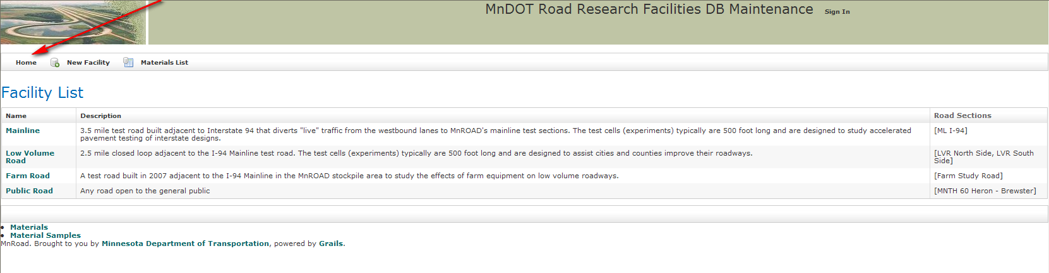
Figure 1
From this screen, to enter a section, click on the green button for which road you would like to enter shown in Figure 1A.
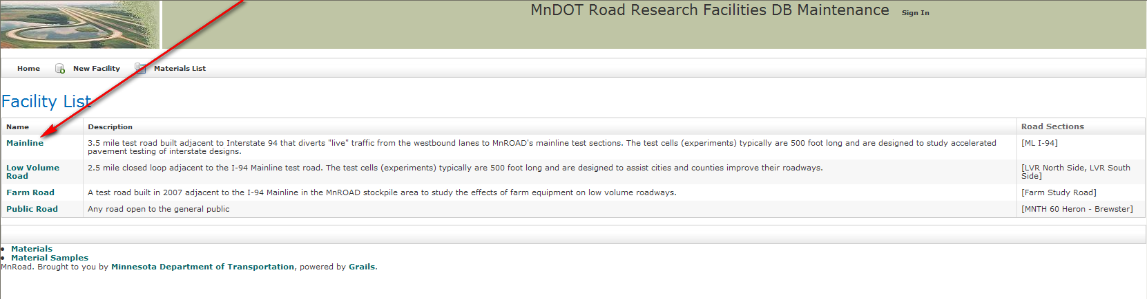
Figure 1A
Your screen will then look similar to this. You will need to click on the green button next to the line named “Road Section*) (Figure 1B).
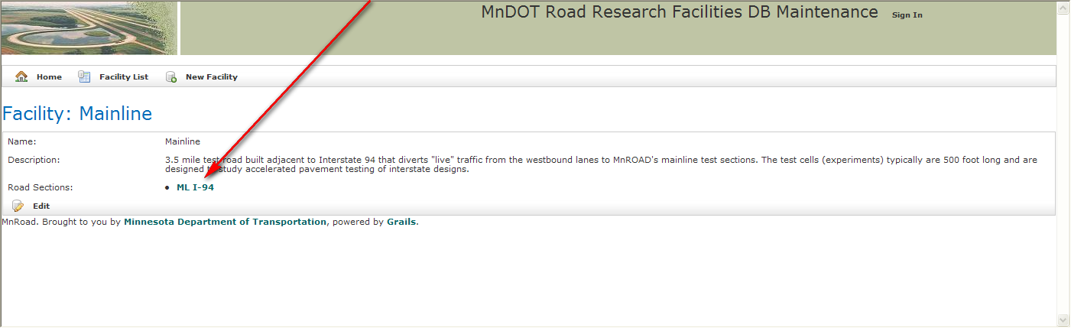
Figure 1B
* Note that in the Low Volume Road there will be two options the “LVR North Side” and “LVR South Side”.

Once you have clicked on the green button you will enter the road section you have chosen in the database. Here you will find a list of all the current cells (Figure 1C). These cells are listed in order of station number.
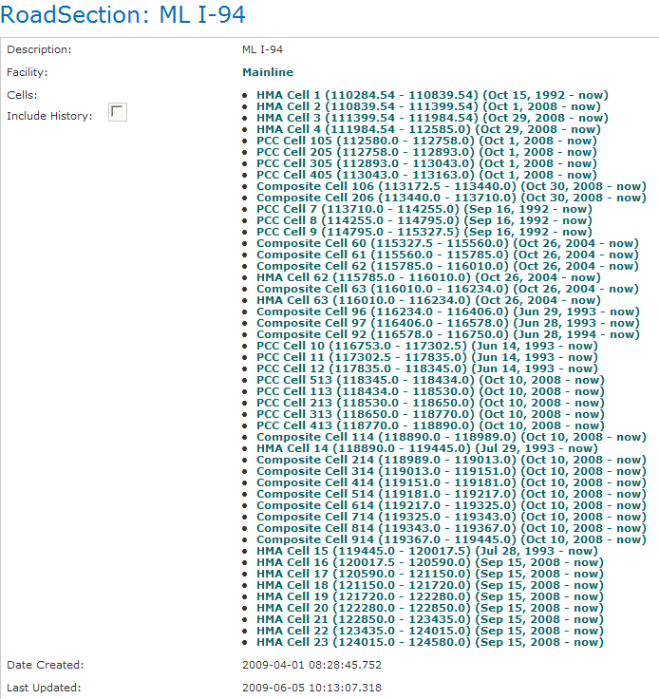
Figure 1C
In order to view cells that no longer exist or have been completely reconstructed you need to check the box that states “Include History” next to it (Figure 1D). The cells that no longer exist or have been reconstructed will appear (in order of station number) within a list similar to Figure 1C.
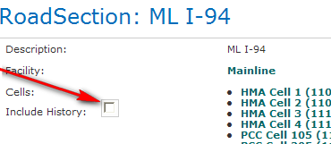
Figure 1D

Creating a New Cell
On the main page for the road section click on the edit button (Figure 2).
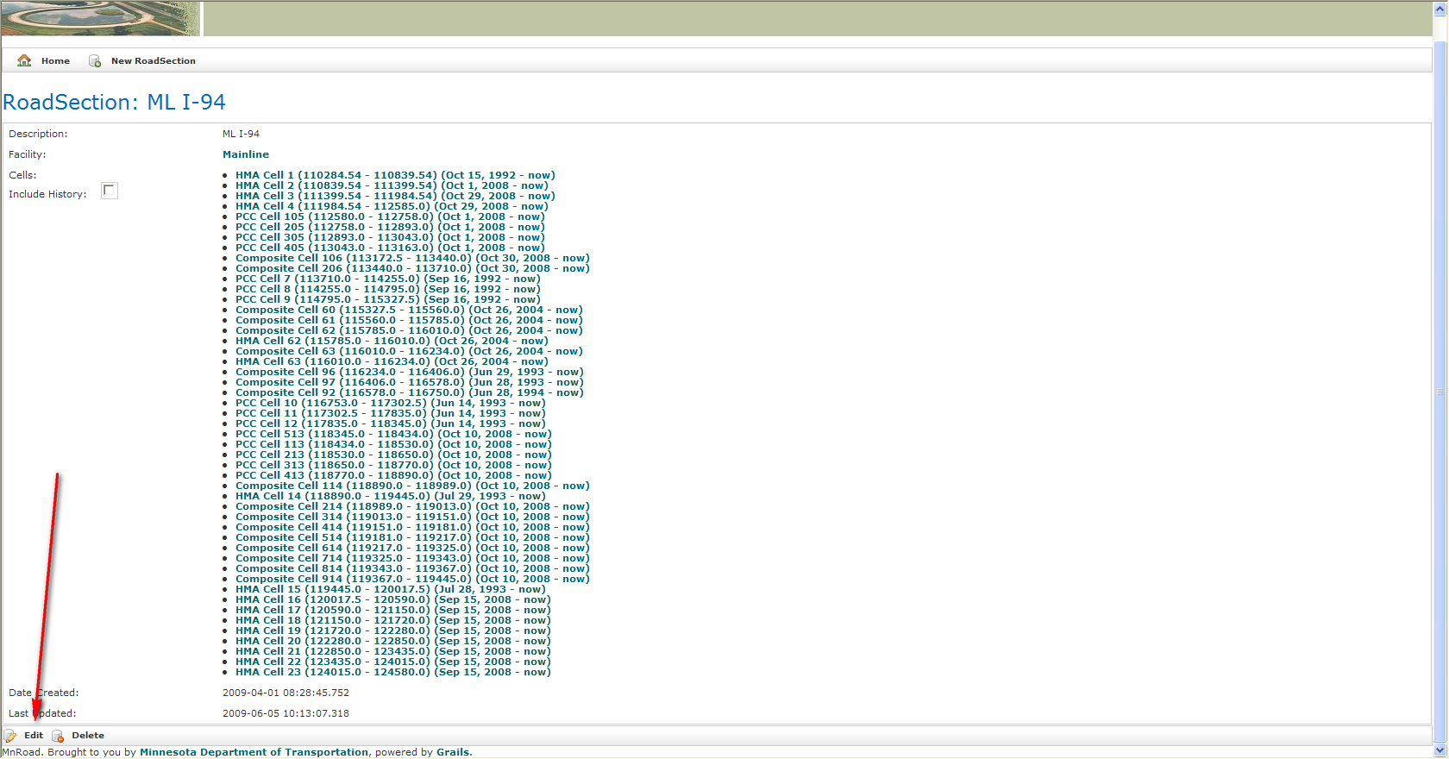
Figure 2
The right side of the screen will look like Figure 2A. Every cell that has already been created will be shown on the bottom half in station order.
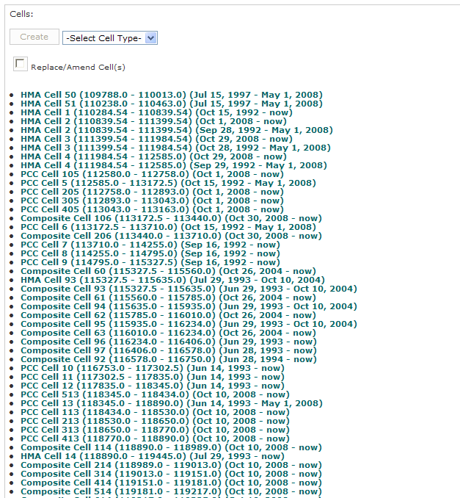
Figure 2A
Shown in Figure 2B, at the top is a scroll down box to select a cell type. Under this scroll down box choose the type of cell you are creating. And click the “create” button next to this scroll down box (Figure 2B).
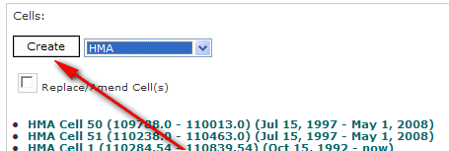
Figure 2B
A screen will appear (Figure 2C), where information about the cell can be entered. Data MUST be entered for the cell number, cell description, cell start station, cell end station, construction ended date, and shoulder type.
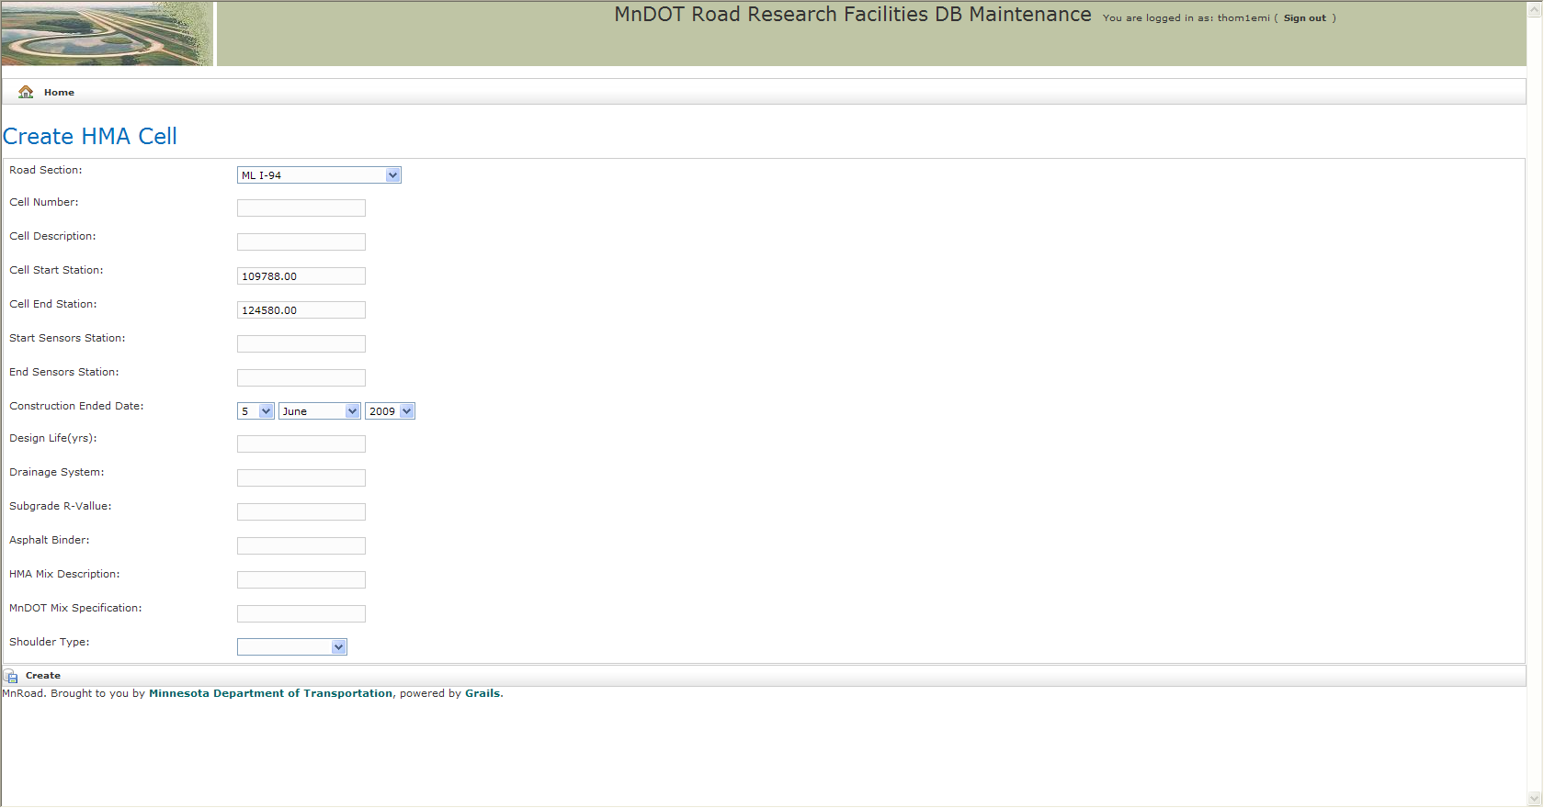
Figure 2C
When you have completed entering data for the cell click the “create” button in the lower left hand corner. You screen will then look similar to Figure 2D.
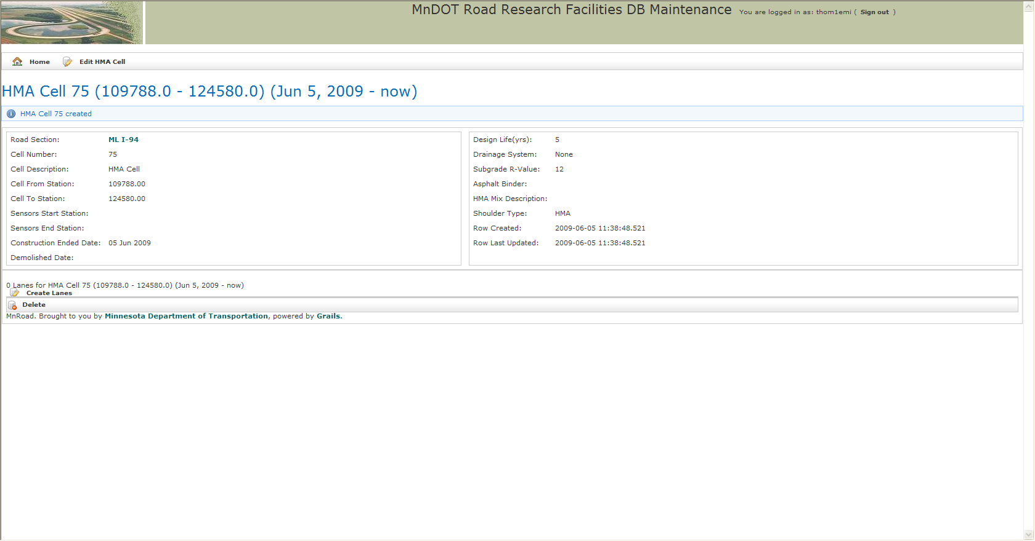
Figure 2D
At this point the new cell is created and will appear in the list of cells on the main page, as shown in Figure 1C.

Creating a Cell as an Overlay
* This procedure is to be used only if the cell(s) is an overlay or some of the original materials are being used again. If the cell is being completely reconstructed the original cell should be given a Demolished Date and a new cell should be created for the cell(s) replacing the original (See “Creating a New Cell).

Prepare original cell, so that all layers are dated properly and there is NO demolish date set*.

In the main page of the road section, click the “edit” button as shown in Figure 3.
Figure 3
On the right hand side check the box stating, “Replace/Amend cell(s)” (Figure 3A).
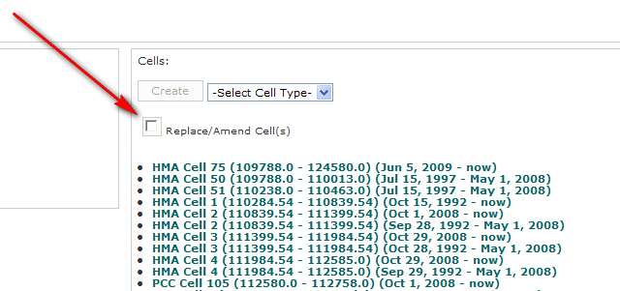
Figure 3A
Choose the cell(s) that are being overlaid from the box that appears (Figure 3B).
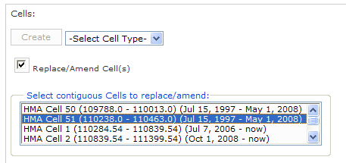
Figure 3B
The left side of the screen will then show a menu (Figure 3C).
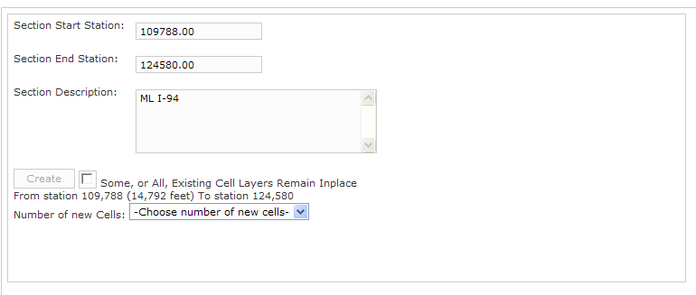
Figure 3C
Choose the number of new cells to create. Once these are chosen the number of new cells will appear below (Figure 3D).
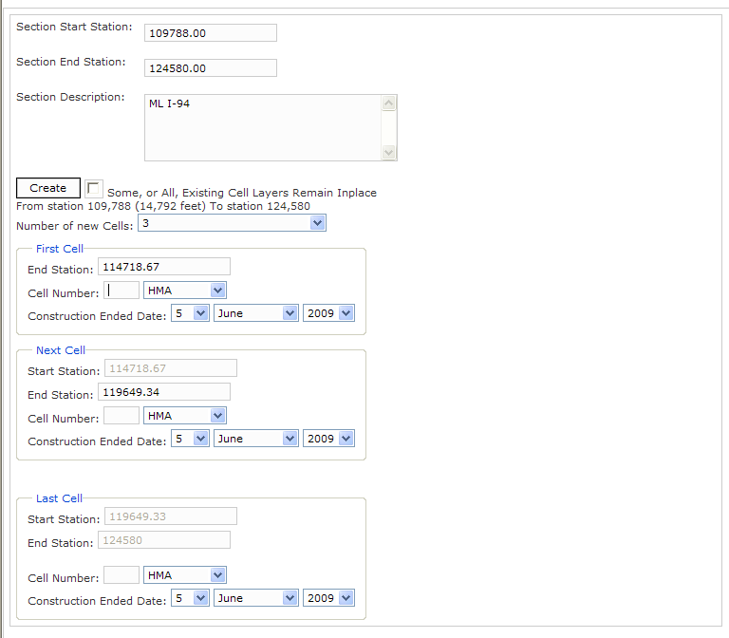
Figure 3D
The new cells are placed in station order. The stations are prefigured, to change them you will type in the new ending station in each cell.

Next, type in the new cell number, choose the type of cell, and the construction ended date for each new cell.

Before clicking “create” make sure to check the box next to the “create” button* (Figure 3E).
* This box is saying some or all of the layers of the original cell are still in place and only part of the layers are being replaced.
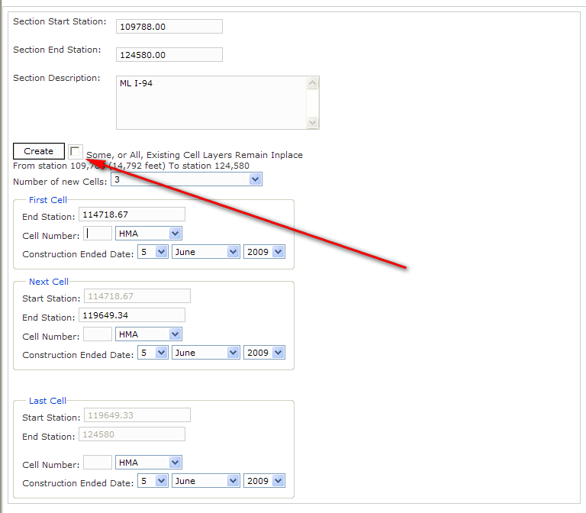
Figure 3E
Then click the “create” button.
At this time the first cell (one with the lowest station number) will appear (Figure 3F).
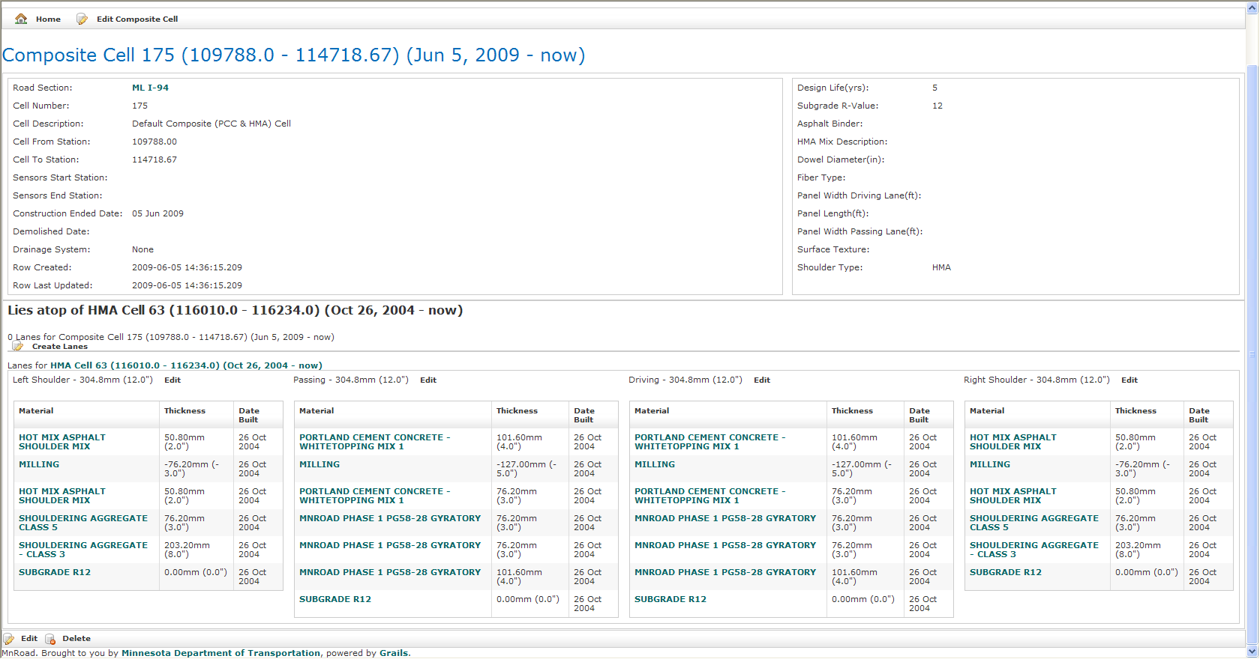
Figure 3F
You will need to create lanes for this new cell (See “Creating Lanes within a cell”).
Then you will add layers (See “Adding a layer within a cell”). You need to start with the milling (should be a negative number) and then add all the materials added in order from the bottom- up. When you are done adding the new layers the cell will look similar to Figure 3G.
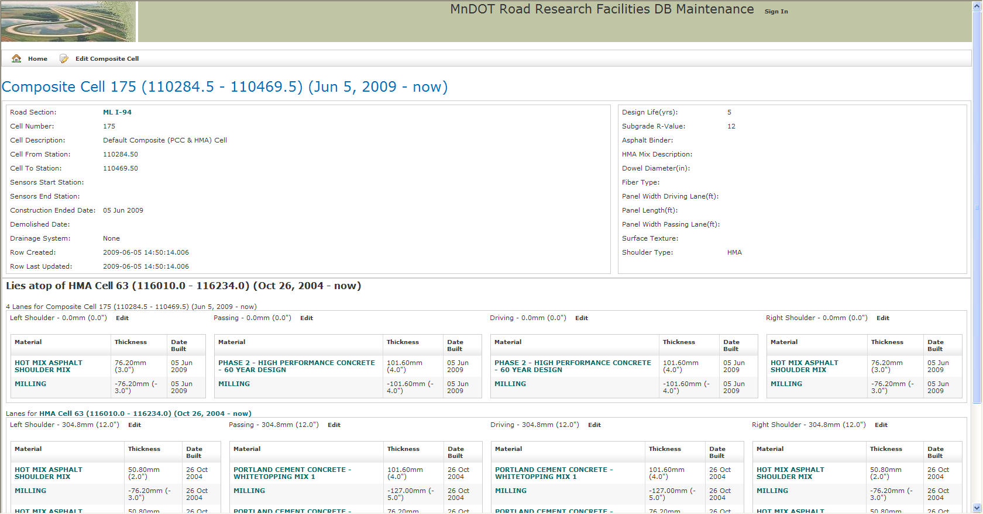
Figure 3G

Creating lanes within a cell
Click on the cell number from the list of cells as shown in Figure 1C. The main screen for the cell will appear (Figure 4).
Figure 4
Click on the “Create Lanes” button in the lower left hand corner (Figure 4B).
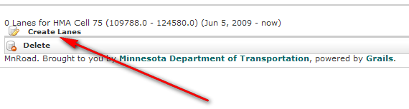
Figure 4B
The screen will then look like what is shown in Figure 4C.
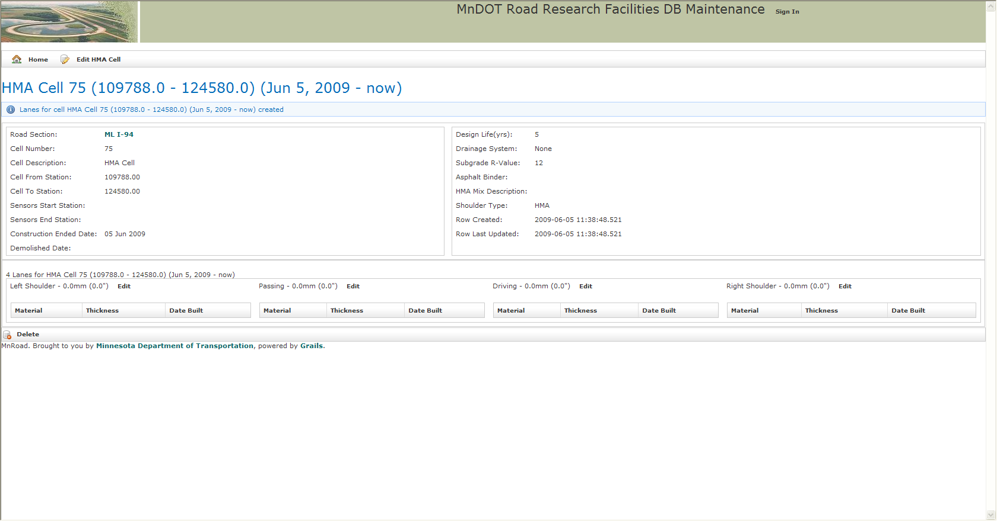
Figure 4C
The lanes are now created for the cell. This will need to be done for each cell created.

Editing General Cell Information
On the cells main page the general information is located on the top half of the page, as shown in Figure 5.
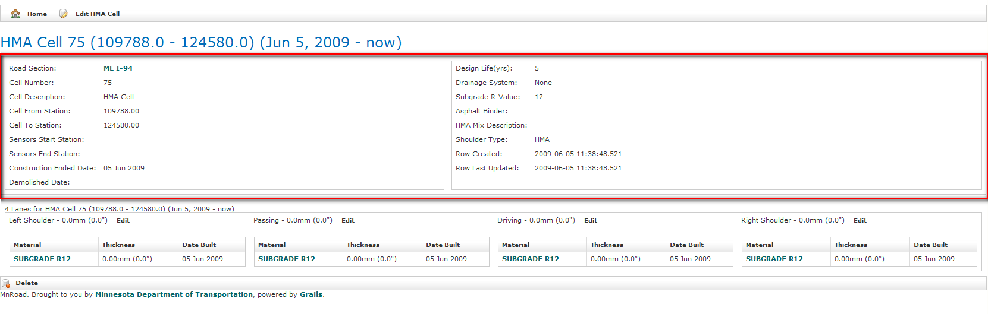
Figure 5
To edit this information, click on the “Edit” button at the top of the page (Figure 5A).
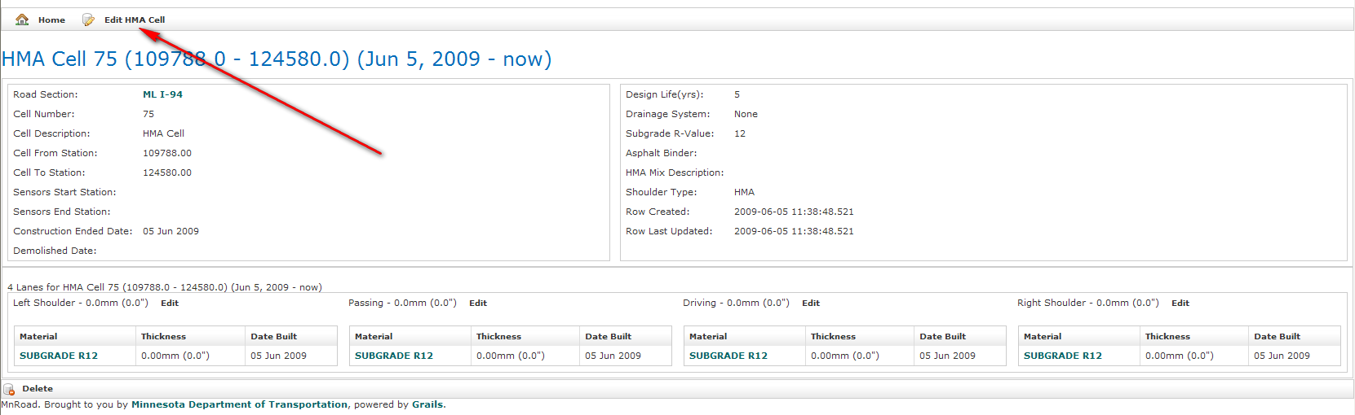
Figure 5A
The screen will then appear like that of Figure 5B.
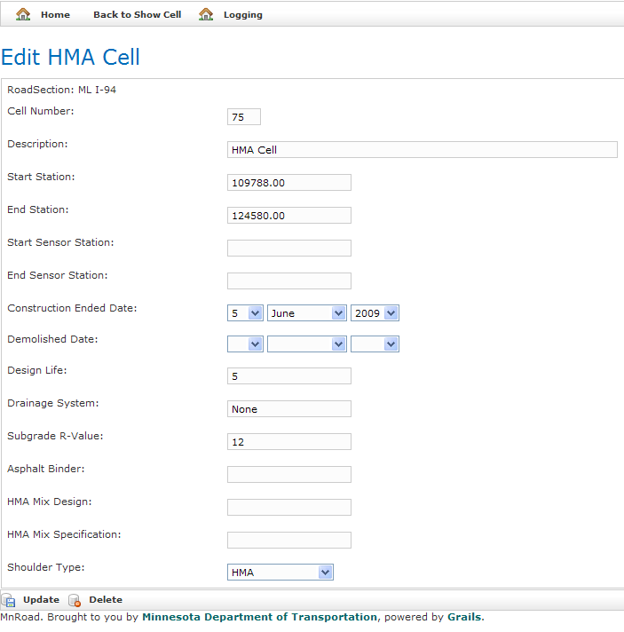
Figure 5B
Here you can enter any information that may have been left out when the cell was created*.
*It is important to note that if the demolished date is set and you cannot edit any information having to do with the layers in the cell. It is best if everything is up to date and complete with the layers before you set the demolish date, if one exists.

When all the data is entered, then click the “Update” on the lower left hand side of the page.

Adding a Layer within a Cell
Click on the cell number from the list of cells as shown in Figure 1C. The main screen for the cell will appear (Figure 4C).

Above the lanes is a button that says edit*. Click the “edit” button above the lane or shoulder you would like to add a layer to, at this time the screen will look like Figure 6.
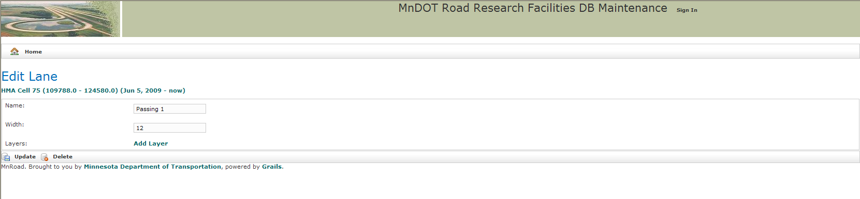
Figure 6

* If the “edit” button is not present you will have to go into the general information of the cell and delete the “Demolished Date” until you are completely finished adding layers to the driving and passing lanes and both shoulders (See “Editing General Cell Information”).

Click the “Add Layer” button (Figure 6A).
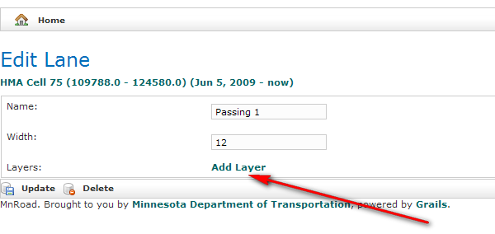
Figure 6A

Select the Start and End Construction Date*, the Material Type, and enter the thickness**.
* If the start and end construction dates are not known at the time leave them to the dates that are set, this can be modified later on (See “Changing information on an existing layer”).
** If the thickness is entered in inches be sure to check the box next to it the states “convert inches to metric”

If this layer is to be added to the other lanes and/ or the shoulders click the box(s) at the bottom to ensure they will be placed in the appropriate places (Figure 6B).

It is important to note, that the layers need to be created from the bottom- up, starting with the subgrade to the actual surface of the road.
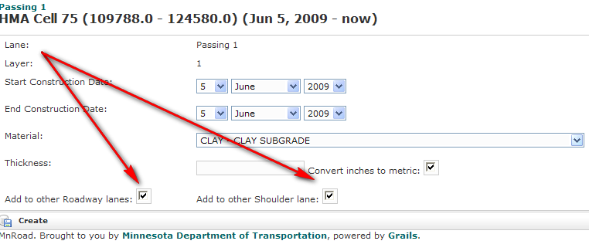
Figure 6B

When everything is entered, click the “create” button. The screen will appear as shown in Figure 6C. To return to the cells main page the cells information under the title “Show Lane” as shown in Figure 6C. If you would like to create more layers repeat this process.
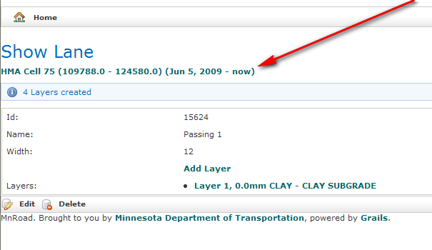
Figure 6C

Once you have added a layer the main cell screen will look similar to Figure 6D.
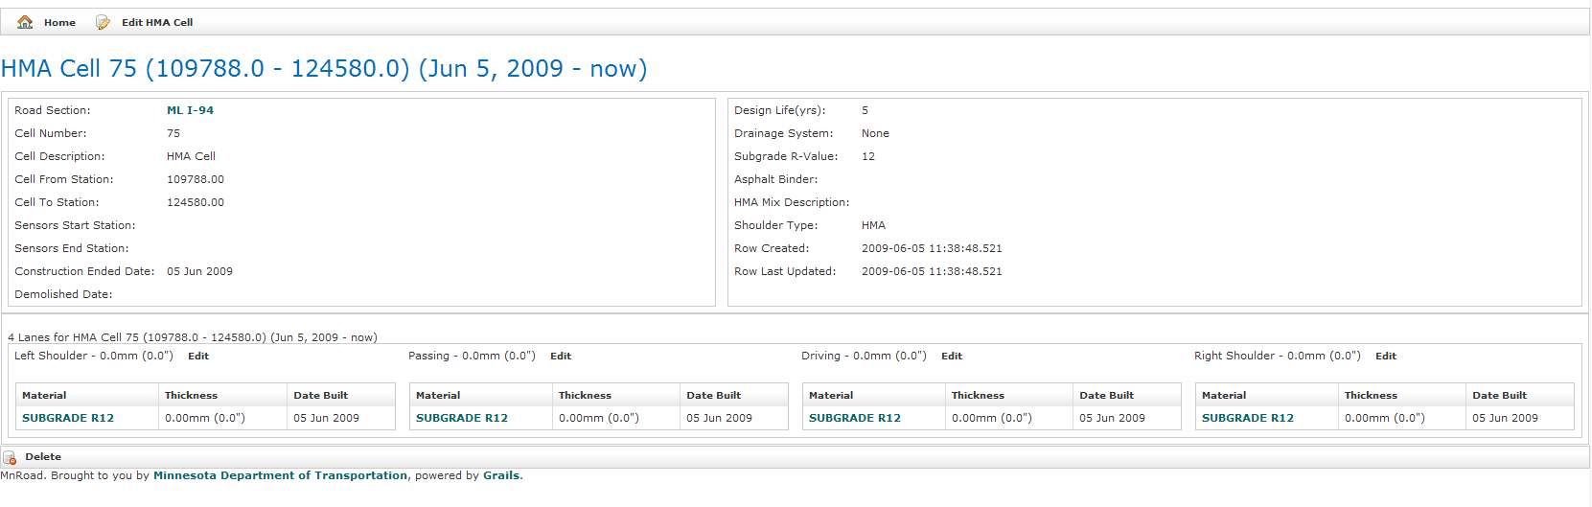
Figure 6D

Changing Information on an Existing Layer
On the main page of the cell, click on the layer you wish to edit (Figure 7).
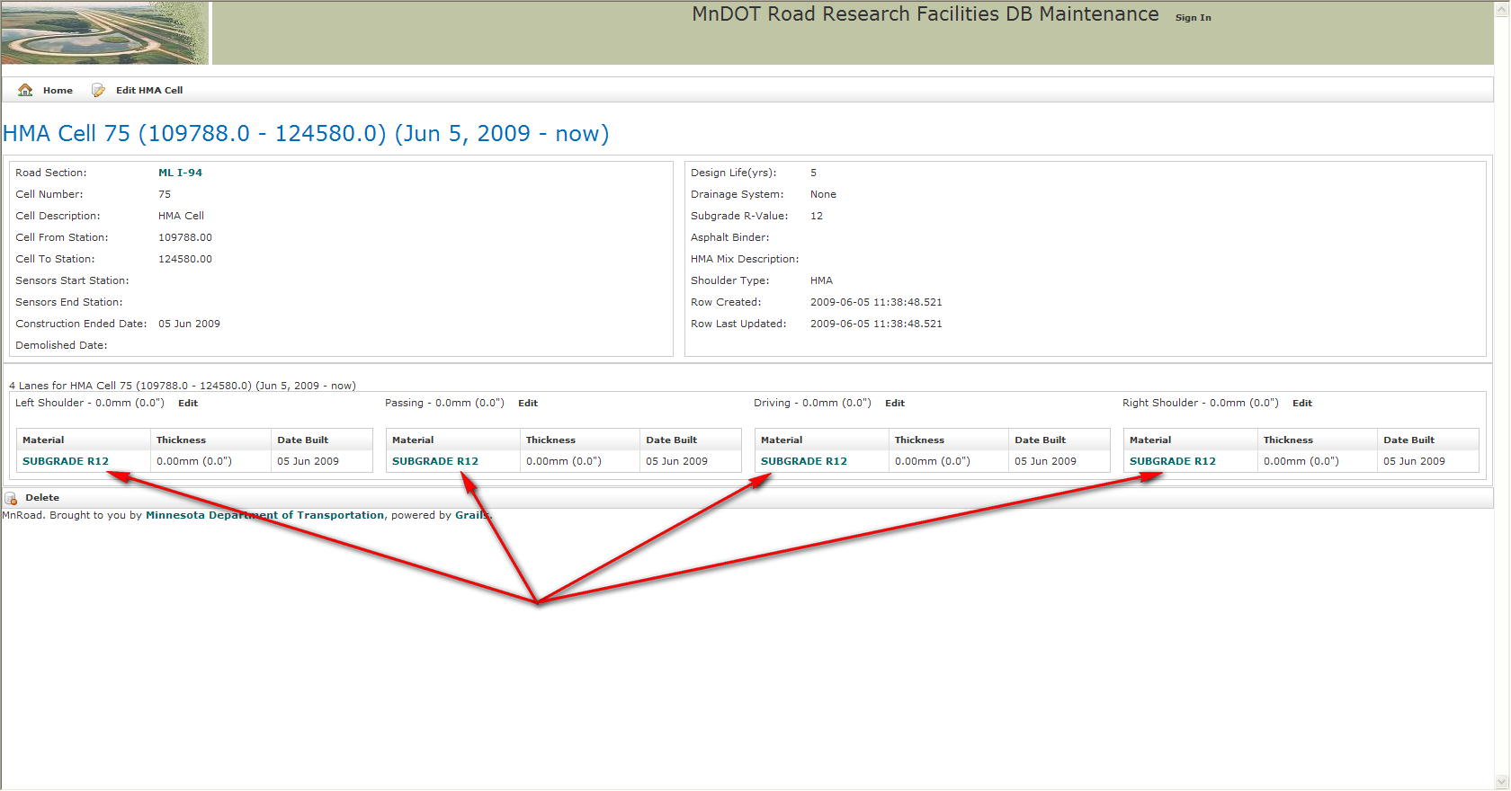
Figure 7

The next page will appear telling you all the information for that layer. Click the “edit” button (Figure 7A).
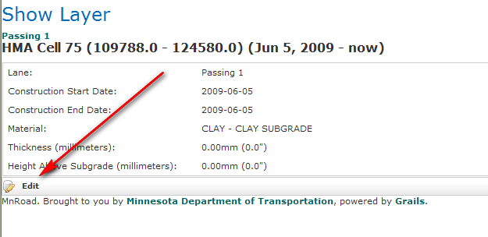
Figure 7A

Edit the layer information and then click ‘update” in the lower left hand corner. This will bring you back to the page shown in Figure 6C.

To edit more layers in this lane, click on the green button under the title “Show Layer” (Figure 7B) and, follow this procedure again*.
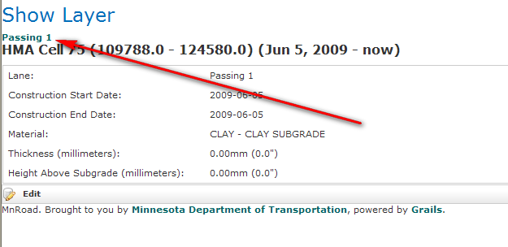
Figure 7B
* If you do not want to edit anymore layers in this lane still click on the green button shown in Figure 7B, and then click on the green button as shown in Figure 2C to return to the main cell menu.
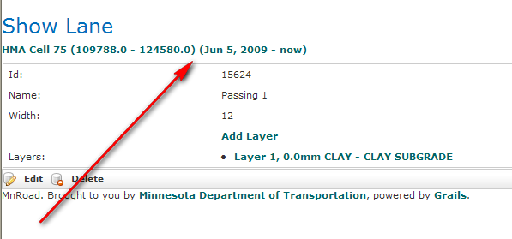
Figure 7C

Returning to the List of Cells When in an Individual Cell
At any point in time you can return to the list of cells from a cells main menu by clicking on the “ML I-94” button (Figure 8)*.
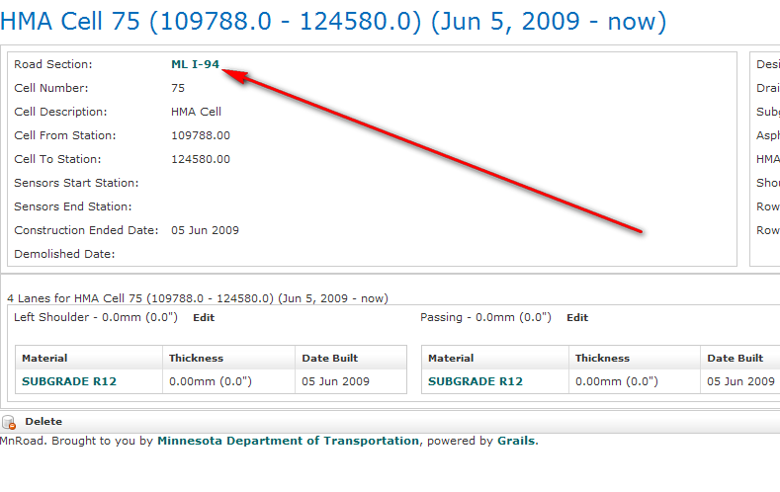
Figure 8
* This option is always available, but it is easiest if you open a new window or tab in your browser when you enter a cell so you can go back a forth faster.

Returning to the Main Menu
At any point in time you can return to the main menu (Figure 9) by clicking on the “home” button (Figure 9A).
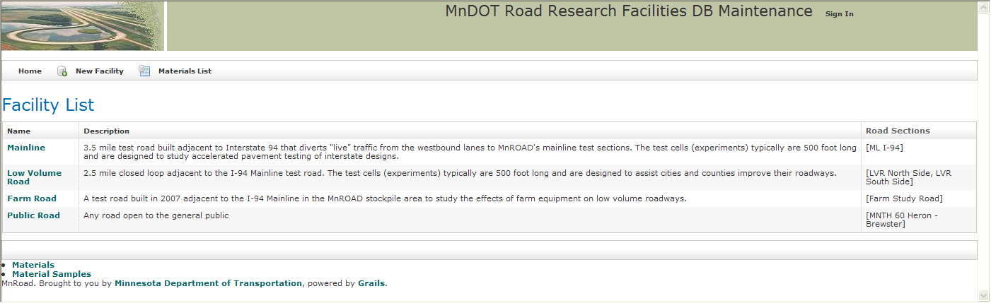
Figure 9
Figure 9A

Managing Users

Add a user from the Mn/DOT Active Directory

Users/Roles/Rights
New MnROAD User
Type in MnDOT user name. e.g. last1fir
Create
Manage Rights
Select MRL Dfs Research Section
Select the username and click <
Update
Cell Location Summary
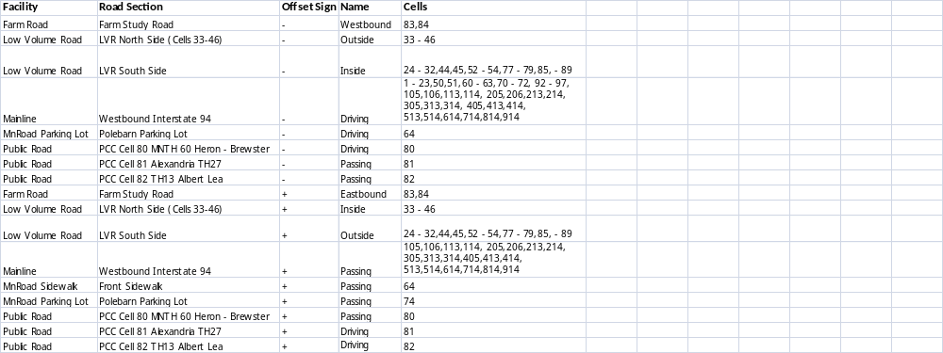
For Developers
Data Export/Import

Use the Oracle “exp” and “imp” commands. Examples are in the files dbexportProd.bat and dbImport.bat.

- Create a new project with the IDE under the appropriate version folder. The new version of Grails must be installed and referenced during the project creation process.
- Copy the source: - the entire grails-app folder, the src/groovy and src/java folders, and application specific files in the web-app folder (images/mnroad.jpg, css/main.css,mnr.css,style.css, and js/application.js)
- Open a console window at the new project folder, set the correct grails version if necessary, and install plugins (jsecurity and help-balloons v1.2)
  - grails install-plugin help-balloons 1.2
  - grails install-plugin jsecurity

Development Process

- Check out source from version control. It is very important that the code in version control reflect what is currently running in production.
- Make changes appropriate for your task.
- Test the changes in the development environment (worstation & local DB).
- Once satisfied that changes are correct, update the local source code with a CVS update to get any updates checked in by other devlopers.
- Build (grails test war) a test executable and deploy it in the test environment (mrl2k3dev & test DB).
- Test the changes in the test environment
- Once satisfied that changes are correct, update the local source code with a CVS update to get any updates checked in by other devlopers.
- Build (grails prod war) a production executable and deploy it.
- Check in updates to version control.

Natural Keys
Candidate natural keys can be identified using a query of this form:

SELECT some,list,of,columns
FROM MNR.table_name
GROUP BY the,same,list,of,columns
HAVING COUNT(*)>1
;

A query returning no rows indicates that the columns in the list form a potential, or candidate, key.
It is up to the domain expert to say whether the data for that set of columns uniquely identifies the row.

Domain Objects
Domain objects represent those entities of promary importance to the client.
Here is an example:

class MatConcAirVoidResults implements Serializable {
static mapping = {
table 'MAT_CONC_AIR_VOID_RESULTS'
// version is set to false, because it isn't available in the table
version false
id composite:['mnroadId']
}
String id
String mnroadId
Date dateTested
java.math.BigDecimal percentAir
Integer specificSurface
java.math.BigDecimal spacingFactor
java.math.BigDecimal voidsPerInch
java.math.BigDecimal pasteToAir
String comments

static constraints = {
mnroadId(size: 1..11, blank: false)
dateTested(nullable: true)
percentAir(nullable: true, scale: 2)
specificSurface(nullable: true)
spacingFactor(nullable: true, scale: 4)
voidsPerInch(nullable: true, scale: 2)
pasteToAir(nullable: true, scale: 2)
comments(nullable: true, size: 0..80)
}
String toString() {
return "${mnroadId}"
}
}

Domain objects will most often map directly to DB tables. Here is the table definition for the MatConcAirVoidResults object:

COLUMN_NAME TYPE_NAME IS_NULLABLE DECIMAL_DIGITS COLUMN_SIZE
MNROAD_ID VARCHAR2 NO <null> 11
DATE_TESTED DATE YES <null> 7
PERCENT_AIR NUMBER YES 2 4
SPECIFIC_SURFACE NUMBER YES 0 4
SPACING_FACTOR NUMBER YES 4 6
VOIDS_PER_INCH NUMBER YES 2 4
PASTE_TO_AIR NUMBER YES 2 4
COMMENTS VARCHAR2 YES <null> 80

These are essentially two different ways of representing the same information.

Database Views

MNR.CELL_ON_CELL
The CELL_ON_CELL view shows information about cells underneath or built atop of other cells. It
provides a means to access data about complex road structures that result from partial reconstruction of cells. CELL_ON_CELL is used in the CELL_SENSORS view to identify

A typical use:
SELECT * FROM MNR.CELL_ON_CELL C
WHERE C.CELL_OVER IN (SELECT (SELECT CELL_NUMBER FROM MNR.CELL WHERE ID=CELL_ID) FROM MNR.CELL_CELL CC JOIN MNR.CELL C ON C.ID=CC.CELL_COVERED_BY_ID)

Table Dependencies
CELL, CELL_CELL

Source
SQL source for CELL_ON_CELL is in sql/viewCellOnCell.sql of the mnroad module in CVS.
Generated Columns:
ID_UNDER
CELL_UNDER
CLASS_UNDER
FROM_STATION_UNDER
TO_STATION_UNDER
FROM_DATE_UNDER
TO_DATE_UNDER
ID_OVER
CELL_OVER
CLASS_OVER
FROM_STATION_OVER
TO_STATION_OVER
FROM_DATE_OVER
TO_DATE_OVER

MNR.CELL_DATES
The CELL_DATES view shows cell information that includes active datess.

MNR.CELLS
The CELLS view shows information about cells underneath or built atop of other cells. It

MNR.SENSORS
The SENSORS view combines SENSOR and SENSOR_MODEL data.

MNR.CELL_SENSORS
The CELL_SENSORS view provides a way to access the CELL_NUMBER associated with the layer in which a sensor is embedded and the CELL_NUMBER associated with the surface layer.

-- Sensors retrofitted into the original layers of Cell
-- and within the longitudinal bounds of the cell
SELECT
S.ID
,SM.MODEL
,S.SEQ
,S.STATION_FT STATION
,S.OFFSET_FT OFFSET
,S.SENSOR_DEPTH_IN DEPTH
,TO_CHAR(S.DATE_INSTALLED,'YYYY-MM-DD') INSTALLED
,TO_CHAR(S.DATE_REMOVED,'YYYY-MM-DD') REMOVED
,UC.CELL_UNDER CELL
,SUBSTR(UC.CLASS_UNDER,24) TYPE
,LN.NAME LANE,M.BASIC_MATERIAL
,UC.FROM_STATION_UNDER FR_STATION
,UC.TO_STATION_UNDER TO_STATION
,TO_CHAR(UC.FROM_DATE_UNDER,'YYYY-MM-DD') FR_DATE
,TO_CHAR(UC.TO_DATE_UNDER,'YYYY-MM-DD') TO_DATE
,'Under' POSITION
,UC.CELL_OVER CELL_O,SUBSTR(UC.CLASS_OVER,24) TYPE_O
,UC.FROM_STATION_OVER FR_STATION_O
,UC.TO_STATION_OVER TO_STATION_O
,TO_CHAR(UC.FROM_DATE_OVER,'YYYY-MM-DD') FR_DATE_O
,TO_CHAR(UC.TO_DATE_OVER,'YYYY-MM-DD') TO_DATE_O
,LN.ID LANE_ID,L.ID LAYER_ID,M.ID MATERIAL_ID
FROM
(SELECT * FROM MNR.CELL_ON_CELL C
WHERE C.CELL_OVER IN (SELECT (SELECT CELL_NUMBER FROM MNR.CELL WHERE ID=CELL_ID) FROM MNR.CELL_CELL CC JOIN MNR.CELL C ON C.ID=CC.CELL_COVERED_BY_ID)
) UC
JOIN MNR.LANE LN ON LN.CELL_ID=UC.ID_UNDER
JOIN MNR.LAYER L ON L.LANE_ID=LN.ID
JOIN MNR.SENSOR S ON S.LAYER_ID = L.ID
JOIN MNR.SENSOR_MODEL SM ON S.SENSOR_MODEL_ID = SM.ID
JOIN MNR.MATERIAL M ON L.MATERIAL_ID=M.ID
-- Show those within the longitudinal bounds of the cell
WHERE S.STATION_FT BETWEEN UC.FROM_STATION_OVER AND UC.TO_STATION_OVER
UNION ALL
-- Sensors embedded in layers built on top of Cell
SELECT
S.ID
,SM.MODEL
,S.SEQ
,S.STATION_FT STATION
,S.OFFSET_FT OFFSET
,S.SENSOR_DEPTH_IN DEPTH
,TO_CHAR(S.DATE_INSTALLED,'YYYY-MM-DD') INSTALLED
,TO_CHAR(S.DATE_REMOVED,'YYYY-MM-DD') REMOVED
,UC.CELL_OVER CELL
,SUBSTR(UC.CLASS_OVER,24) TYPE
,LN.NAME LANE,M.BASIC_MATERIAL
,UC.FROM_STATION_OVER FR_STATION
,UC.TO_STATION_OVER TO_STATION
,TO_CHAR(UC.FROM_DATE_OVER,'YYYY-MM-DD') FR_DATE
,TO_CHAR(UC.TO_DATE_OVER,'YYYY-MM-DD') TO_DATE
,'Over' POSITION
,UC.CELL_UNDER CELL_O,SUBSTR(UC.CLASS_UNDER,24) TYPE_O
,UC.FROM_STATION_UNDER FR_STATION_O
,UC.TO_STATION_UNDER TO_STATION_O
,TO_CHAR(UC.FROM_DATE_UNDER,'YYYY-MM-DD') FR_DATE_O
,TO_CHAR(UC.TO_DATE_UNDER,'YYYY-MM-DD') TO_DATE_O
,LN.ID LANE_ID,L.ID LAYER_ID,M.ID MATERIAL_ID
FROM MNR.CELL_ON_CELL UC
JOIN MNR.LANE LN ON LN.CELL_ID=UC.ID_OVER
JOIN MNR.LAYER L ON L.LANE_ID=LN.ID
JOIN MNR.SENSOR S ON S.LAYER_ID = L.ID
JOIN MNR.SENSOR_MODEL SM ON S.SENSOR_MODEL_ID = SM.ID
JOIN MNR.MATERIAL M ON L.MATERIAL_ID=M.ID

Debug Console Scripts
// Implicit variables available to any script include:
// ctx: the Spring application context
// grailsApplication: the Grails application
// config: the Grails configuration
// request: the HTTP request
// session: the HTTP session
// In the debug console use ctx.sessinFactory instead of def sessionFactory
// This example scrip will export
import groovy.sql.Sql
import org.codehaus.groovy.grails.commons.ConfigurationHolder
import org.codehaus.groovy.grails.commons.ApplicationHolder
import org.codehaus.groovy.grails.commons.DefaultGrailsDomainClass
def sql = Sql.newInstance(ConfigurationHolder.config.dataSource.url as String,
ConfigurationHolder.config.dataSource.username as String,
ConfigurationHolder.config.dataSource.password as String,
ConfigurationHolder.config.dataSource.driverClassName)
def domainObjList = ApplicationHolder.application.getArtefacts("Domain") as List
def exportData = grailsApplication.config.exportOrder["data"]
def nTables = exportData.size()
exportData.each { cn ->
domainObjList.each { domObj ->
if (domObj.shortName.endsWith(cn)) {
int rowidx = 0
def cls = domObj.newInstance()
if (cls && (!domObj.shortName.equals("Cell"))) { // class Cell is extended
def sn = domObj.clazz.name.substring(domObj.clazz.name.lastIndexOf('.')+1)
def metaData = props(domObj.clazz.name)
def objs = cls.list()
if (objs.size() < grailsApplication.config.maxExportRowsPerTable) {
def fn = "mr${sn}Data.csv"
println "Writing ${objs.size()} rows to file ${fn}"
FileWriter fw
try {
fw = new FileWriter(fn);
def ls = System.getProperty( "line.separator", "\n" )
fw.append(metaData['columns'].join(",")+ls)
objs.each { arow ->
def line = ""
def flds = metaData["fields"]
flds.eachWithIndex { obj, i ->
def type = metaData["types"].toArray()[i].name
def val = arow[obj]
String sqlVal = ""
if (!type.equals("java.util.Set") && !type.equals("java.util.SortedSet")) {
sqlVal = formatSqlValueForCsv(val, type,!metaData["fks"].toArray()[i].equals(""))
}
line += i?",":""
line += sqlVal
line += (i==metaData["fields"].size()-1)?"${ls}":""
}
fw.append(line)
}
fw.close();
} catch(java.io.FileNotFoundException fnfe) {
if (fnfe.message.endsWith( "(The process cannot access the file because it is being used by another process)"
)) {
println fnfe.message
}
} catch(Exception e) {
println e.message
}
}
}
}
}
}
private def props(topLevelName) {
def rc = [:]
//get the domain class object named topLevelName
def domainClass = grailsApplication.getClassForName(topLevelName)
//get hibernage meta data object
def hibernateMetaClass = ctx.sessionFactory.getClassMetadata(domainClass)
//get the table name mapped to the DomainClass domain class
def tableName = hibernateMetaClass.getTableName()
rc.put("tableName",tableName)
rc.put("discriminatorColumnName",hibernateMetaClass.discriminatorColumnName)
// Create a new GrailsDomainClass object for the DomainClass
// hibernateMetaClass.propertyMapping.typesByPropertyPath
// hibernateMetaClass.propertyMapping.columnsByPropertyPath
def grailsDomainClass = new DefaultGrailsDomainClass(domainClass)
//get the domain properties defined in Domain Class
def domainProps = grailsDomainClass.getProperties()
def fields = []
def types = []
def columns = []
def fks = []
domainProps.each {prop ->
//get the property's name
String propName = prop.getName()
def columnProps = null
try {
columnProps = hibernateMetaClass.getPropertyColumnNames(propName)
}
catch (org.hibernate.MappingException hme) {
//println "${hme.message}"
// "Table: $tableName, MappingException message: ${hme.message}."
// caused by having closures in domain classes e.g. unknown property: depthRange
}
if (columnProps && columnProps.length > 0) {
//get the column name, which is stored into the first array
def columnName = columnProps[0]
String pn = propName.toString()
fields.add(pn)
types.add(prop.type)
columns.add(prop.naturalName.toUpperCase().replace(' ','_'))
if (!prop.isOwningSide() && prop.isManyToOne() && columnName.endsWith("_id")) {
fks.add(pn)
}
else if (prop.isOneToMany() && prop.referencedPropertyType != null) {
fks.add(prop.referencedPropertyType.name)
}
else if (prop.isOneToOne()) {
fks.add(prop.type)
}
else {
fks.add("")
}
}
}
rc.put("fields",fields)
rc.put("types",types)
rc.put("columns",columns)
rc.put("fks",fks)
return rc
}
private String formatSqlValueForCsv(Object val, String typ, Boolean useId) {
String rc = ""
if (typ.equals("java.util.Date")) {
def fd = val == null?"":"${val}"
if (fd.endsWith(" 00:00:00.0"))
rc = fd.split(" ")[0]
else {
rc = fd?fd.substring(0,fd.lastIndexOf(":")):""
}
}
else if (typ.equals("java.lang.String")) {
if (val == null)
return "\"\""
if (val.contains("\'")) {
def s = val
def n = s.replace("\'","\'\'")
rc = "\"$n\""
}
else
rc = "\"${val}\""
}
else if (typ.equals("java.lang.Long")) {
rc = val == null?"":val
}
else if (typ.equals("java.lang.Double")) {
rc = val == null?"":val
}
else if (typ.equals("java.lang.Boolean")) {
int b = (val?1:0)
rc = val == null?"":"$b"
}
else if (typ.equals("java.lang.Integer")) {
rc = val == null?"":val
}
else {
if (useId)
rc = ""+val?.id
else
println "Unknown type: $typ"
}
return rc
}

For more information: For more information about MnROAD and the Road Research program at MnDOT:

Tim Clyne Ben Worel
Office of Materials & Road Research Office of Materials & Road Research
Phone: 651-366-5473 Phone: 651-366-5522
E-mail: Tim.Clyne@dot.state.mn.us Email: Ben.Worel@dot.state.mn.us

www.dot.state.mn.us/mnroad

